Perspective Projection

In perspective projection farther away object from the viewer, small it appears. This property of projection gives an idea about depth. The artist use perspective projection from drawing three-dimensional scenes.

Two main characteristics of perspective are vanishing points and perspective foreshortening. Due to foreshortening object and lengths appear smaller from the center of projection. More we increase the distance from the center of projection, smaller will be the object appear.

Vanishing Point

It is the point where all lines will appear to meet. There can be one point, two point, and three point perspectives.

**One Point:** There is only one vanishing point as shown in fig (a)

**Two Points:** There are two vanishing points. One is the x-direction and other in the y -direction as shown in fig (b)

**Three Points:** There are three vanishing points. One is x second in y and third in two directions.

In Perspective projection lines of projection do not remain parallel. The lines converge at a single point called a center of projection. The projected image on the screen is obtained by points of intersection of converging lines with the plane of the screen. The image on the screen is seen as of viewer's eye were located at the centre of projection, lines of projection would correspond to path travel by light beam originating from object.

Important terms related to perspective

1. **View plane:** It is an area of world coordinate system which is projected into viewing plane.
2. **Center of Projection:** It is the location of the eye on which projected light rays converge.
3. **Projectors:** It is also called a projection vector. These are rays start from the object scene and are used to create an image of the object on viewing or view plane.

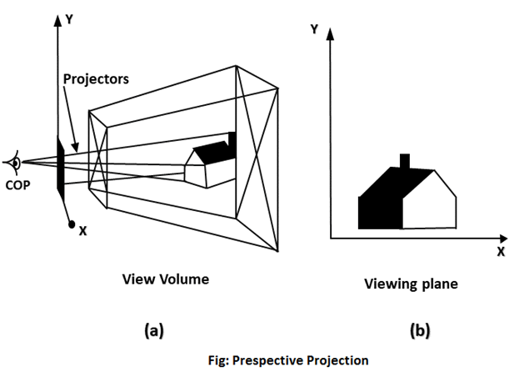

Anomalies in Perspective Projection

It introduces several anomalies due to these object shape and appearance gets affected.

1. **Perspective foreshortening:** The size of the object will be small of its distance from the center of projection increases.
2. **Vanishing Point:** All lines appear to meet at some point in the view plane.
3. **Distortion of Lines:** A range lies in front of the viewer to back of viewer is appearing to six rollers.

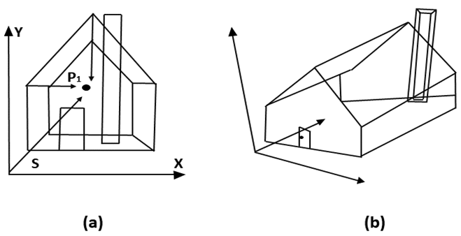  
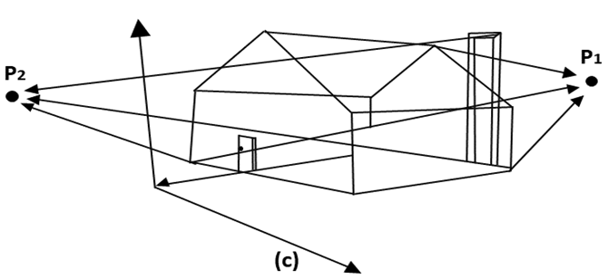

Foreshortening of the z-axis in fig (a) produces one vanishing point, P1. Foreshortening the x and z-axis results in two vanishing points in fig (b). Adding a y-axis foreshortening in fig (c) adds vanishing point along the negative y-axis.